Name: ___________________

Ben’s Research Lesson: what can you remember?

- If the current through A₂ is 0.3A and the current through A₃ is 0.5A, what is the current through A₁?

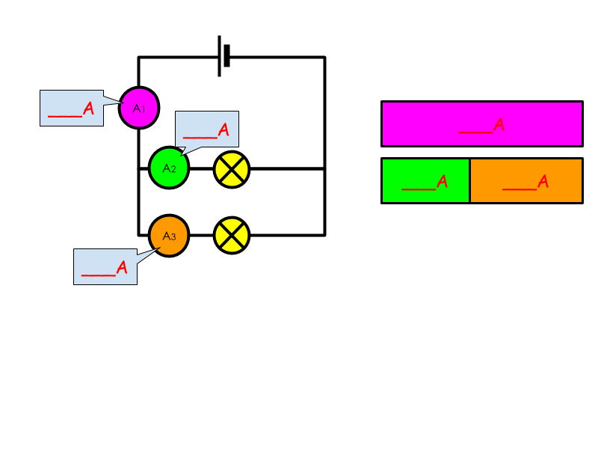

- If the current through A₁ is 1.0A and the current through A₂ is 0.6A, what is the current through A₃?

- If the current through A₁ is 1.5A and the current through A₃ is 0.8A, what is the current through A₂ ?

- If the current through A₁ is 1.0A and the current through A₂ and A₃ is the same, what is the current through A₂ and A₃?

